Functional Programming Languages

📌 Definition:
# Source: AI Source: Provided by: [Data Path: Persons Table -> ID Column: 1, Name_En Column: Motasem Essam] -> From: [Chatgpt (GPT‑5 Mini)] on [12/9/2025]
Functional programming languages are high-level languages that focus on functions, mathematical expressions, and avoiding changing data (immutability).

🧠 Simple idea:
# Source: AI Source: Provided by: [Data Path: Persons Table -> ID Column: 1, Name_En Column: Motasem Essam] -> From: [Chatgpt (GPT‑5 Mini)] on [12/9/2025]
Functional = Think in terms of math functions, not steps or objects

🔍 Key characteristics:
# Source: AI Source: Provided by: [Data Path: Persons Table -> ID Column: 1, Name_En Column: Motasem Essam] -> From: [Chatgpt (GPT‑5 Mini)] on [12/9/2025]
- ✅ Focus on functions as the main building block
- ✅ No side effects (functions don’t change external state)
- ✅ Immutable data (data doesn’t change)
- ✅ Emphasizes pure functions (same input → same output)

🧩 Example:
# Source: AI Source: Provided by: [Data Path: Persons Table -> ID Column: 1, Name_En Column: Motasem Essam] -> From: [Chatgpt (GPT‑5 Mini)] on [12/9/2025]
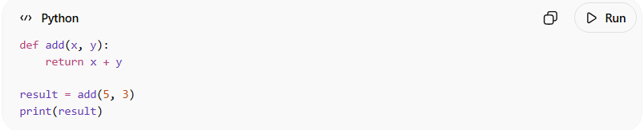
def add(x, y):
return x + y

result = add(5, 3)
print(result)
👉 The function:
- Takes input
- Returns output
- Does not change anything outside

⚙️ How it works:
# Source: AI Source: Provided by: [Data Path: Persons Table -> ID Column: 1, Name_En Column: Motasem Essam] -> From: [Chatgpt (GPT‑5 Mini)] on [12/9/2025]
- Break problems into mathematical functions
- Combine functions to build logic
- Avoid modifying existing data

🧩 Examples of Functional Languages:
# Source: AI Source: Provided by: [Data Path: Persons Table -> ID Column: 1, Name_En Column: Motasem Essam] -> From: [Chatgpt (GPT‑5 Mini)] on [12/9/2025]
- Haskell
- Lisp
- Scala
- Erlang

🔁 Functional vs 🔄 Procedural vs 🧠 OOP

🔁 1. Functional Programming
# Source: AI Source: Provided by: [Data Path: Persons Table -> ID Column: 1, Name_En Column: Motasem Essam] -> From: [Chatgpt (GPT‑5 Mini)] on [12/9/2025]
Focus: Functions and mathematical logic
Data: Immutable (does not change)
Approach: Declarative (what to do, not how)
Example: Haskell, Lisp, Scala
👉 You think in terms of functions and results

🧩 2. Procedural Programming
# Source: AI Source: Provided by: [Data Path: Persons Table -> ID Column: 1, Name_En Column: Motasem Essam] -> From: [Chatgpt (GPT‑5 Mini)] on [12/9/2025]
Focus: Step-by-step instructions (functions/procedures)
Data: Separate from functions
Approach: Top-down
Example: C, Pascal
👉 You tell the computer what to do step by step

🧠 3. Object-Oriented Programming (OOP)
# Source: AI Source: Provided by: [Data Path: Persons Table -> ID Column: 1, Name_En Column: Motasem Essam] -> From: [Chatgpt (GPT‑5 Mini)] on [12/9/2025]
Focus: Objects (data + behavior together)
Data: Encapsulated inside objects
Approach: Bottom-up
Example: Java, C++, Python
👉 You model real-world things (objects)

⚖️ Side-by-Side Comparison
# Source: AI Source: Provided by: [Data Path: Persons Table -> ID Column: 1, Name_En Column: Motasem Essam] -> From: [Chatgpt (GPT‑5 Mini)] on [12/9/2025]
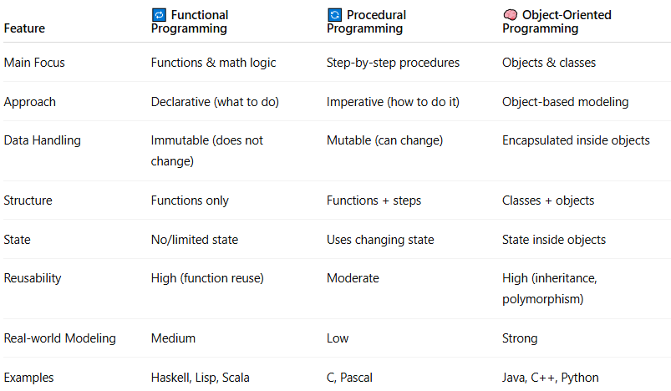
Feature | 🔁 Functional Programming | 🔄 Procedural Programming | 🧠 Object-Oriented Programming
Main Focus | Functions & math logic | Step-by-step procedures | Objects & classes
Approach | Declarative (what to do) | Imperative (how to do it) | Object-based modeling
Data Handling | Immutable (does not change) | Mutable (can change) | Encapsulated inside objects
Structure | Functions only | Functions + steps | Classes + objects
State | No/limited state | Uses changing state | State inside objects
Reusability | High (function reuse) | Moderate | High (inheritance, polymorphism)
Real-world Modeling | Medium | Low | Strong
Examples | Haskell, Lisp, Scala | C, Pascal | Java, C++, Python

✅ Summary:
# Source: AI Source: Provided by: [Data Path: Persons Table -> ID Column: 1, Name_En Column: Motasem Essam] -> From: [Chatgpt (GPT‑5 Mini)] on [12/9/2025]
Functional programming solves problems using pure functions and immutable data, making programs easier to reason about and less error-prone.

